The Real Hunger games
By: Zigzwag1243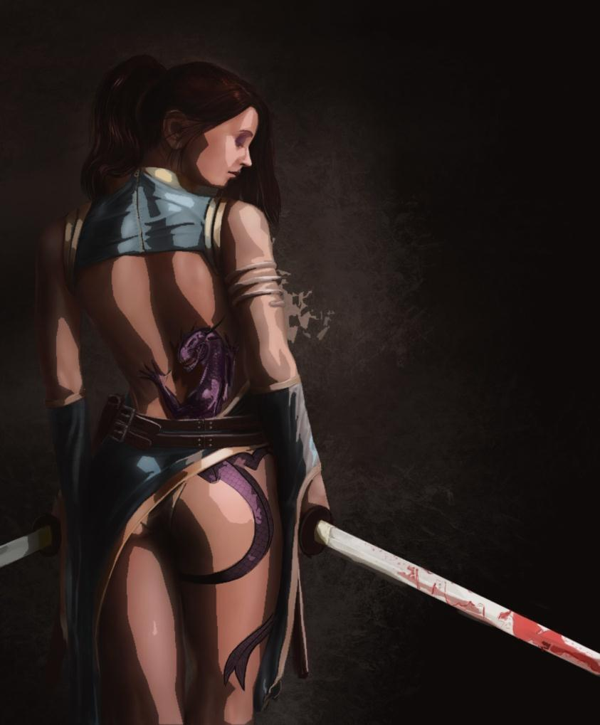
Prologue:
The year is 2145 and the world if once again finally at peace, though the peace doesn’t come without Heart ship. The world has been left scared all that was once the major cities is left in ruin, and long since overtaken by vegetation. All aspects of money/ and power that once was on the forefront gone. Major pockets of radiation force the survivors into barely habitable sectors. Some becoming more prosperous than others, what was once the Central Terra once again becomes a prosperous farming community, and is now called the Citadel. A new City quickly sprouting, But our story doesn’t start here. Our story starts in small town on the far outskirts of the habitable zone So far away from stable food supplies, that they have resorted to an almost barbaric lifestyle, living in huts of mud and wood. The populace forced to live in a hunter gatherer lifestyle. Even though this has been known to work, it doesn’t bring safe drinking water and food enough for everyone to live off of. The Citadel sector knows this, for its water supplies especially in the northern sectors where the lakes, and rivers remained untouched now heavily guarded by the Citadel Defence forces.
The way the Citadel control that gets what amount when is through a competition they hold twice a year, they call it Hunger Games. Here are the rules: people from the less fortunate outer lying sectors, are forced to thrust one individual into one of the most threatening places known to man. A large arena flushed with predators, be they plants, animals, traps. Even if one individual gets betted against, the world itself can be his/her enemy. Each player will be granted Three lives by the Goddess Atheros, A powerful Succubus that now controls the land. The longer your sectors competitor survives the more water and food the Citadel will provide. The winning Sector gets unlimited supplies for the half year. If your three lives do however expire, you are dead. There is no more coming back.
There are Acceptations to this rule however, Should you be picked to become the days hunter, you will be granted Predatory status given the tail of a serpent, You can still be killed this day, by other preds or contestants, yet this death doesn’t go towards your total death tally, you just come back the following day as yourself.
If you are liked enough by the “viewers” Than you can receive care packages containing things like weapons, medication and first aid equipment, And fresh food and water. Although… If you are not liked, than they can send traps, or force creatures to teleport close to you, they cannot kill you outright.

Our Story begins in the small town of Ormuctus on the far edge of the habitable zone, populated primarily by the considered “lesser Races” the Vixens, the canines, the Felines, pretty much all your Anthro races. Yet in this mix of fur, there is one family, The Scott family, a human family that has always been viewed as one of the poorest treated, too low class to live in the human sectors, and blamed by the Anthro’s for their living conditions. In this family was a young woman, Jenifer Scot, A twenty year old beautiful woman her slender figure marred by the dirt as she comes back from hunting, Red hair flowing down her back long and just as dirty as the rest of her. Carrying on her back a group of wild chickens that she managed to catch, Standing at the top of the rocks that protect the city from the predators was her long and only friend, a male Eagle anthro by the name of Frederick
“You know…” He starts hopping down grabbing the bag. “I would have come with you…” He says, his voice strong, just like his figure, the soft coloured brown feathers coat his slender body. easily taking the bag of poultry back up before reaching down to give Jenifer a hand climbing up.
“I know Fred, But hunting is the one thing I am good at…” She smiles. “At least the Town lets me do this, Even if we only get to keep one bird.” She sighs as the two walk down the muddied path.
“You know…” Fred starts, walking off towards her home, secluded and poorly constructed on the outskirts of town. “The Hunger games are going to be starting Today… Roster selections are this afternoon…” The Eagle says glancing down at his long-time friend.
“Tell me about it…” She replies as she adjusts her Bolo that rests on her string belt, the two walking past a pair of female Vixens who glare at Jen, with hate in their eyes. “Who do you think the Unlucky sap will be this year to represent us?” She says smiling as she drops the Chickens off at the butchers, the Wolf anthro growling as he rips it off the counter.
“I don’t know, but you realize that you are of age this year…” Frederick says, in saying that she instantly got a tingling sensation that streamed down her spine.
“Don’t you even dare say it’s going to be me, I won’t believe it.” She says pointing her hand that just so happened to hold a Chicken in it, feeling its weight swaying in her grasp.
“Look, All I am saying is that you’re eligible… I am eligible this year too…” Frederick says dropping the Chicken off at home. “We should get down to the square…” he says pulling on her arm. “They don’t like it when we are late…” He says.
“Ok… I will meet you there, I just want to say goodbye to my mother.” She says slipping her wrists out of his grasp pushing through the dirty mud covered wooden door.
“Mother I am home…” She would say spying her mother, an older woman easily in her seventies was sitting on a wooden stool knitting socks,
“I know dear, I also know where you are going…” She sighs as a tear rolls down her face. “Be safe my child…” She says placing her knitting off to the side standing up rushing over to the side Of Jen wrapping her in a deep hug. “And come home safe…” She says, as if she knows what exactly is going to happen.
“I will mom… I promise…” She says as she lets go turning to leave. “I will be home soon alright?” Jen says leaning in to give her mother a kiss. Before softly slipping out of her grip and heading out the door.
As she entered the center of town the amount of people would double, then triple, and soon enough it was to hard to move, but she had to make it to the Applicants section. The Butcher wolf stood in her way looking down at her
“Looks like we got ourselves a dead girl walking…” He smiles before patting her on the shoulder. “And I was just starting to like your catches.” He would say before moving out of her way. Eventually though she did make it to the front where one of the Citadel sector guards was waiting.
“Potential contestant…” The robotic voice would say “Please this way…” It would say opening a small velvet rope cut off allowing her to pass into the group of selection aged competitors. Finding Frederick he would give her a warm smile as he looks down at her.
“Moment of truth?” he says looking up as an eerie still came about the whole crowd.
“LADIES AND GENTLEMEN OF ORMUCTUS” a voice would say ringing out, as the stage would light up, the curtains would peel apart, “Your regional governor Berook!” a voice would say as a tall lanky peacock would walk out onto the stage, his feathers vibrantly coloured as he made his way to the microphone. Clearing his throat as his low raspy voice echoed across the mud and wood of this little town
“People of Ormuctus! It is time to choose…” Would be his only words, one of the townsfolk would come up to him with an envelope in hand, that was just as dirty as the rest of the citizens, handing it to him before disappearing. “Ahh here we go…” he says as he opens it up pulling the ballet out.
“Your representative, for All the anthro’s is!” he says giving a pause cocking his head to the side “Are you sure? No, this can’t be right…” He says, and his words would start making Jen hold her breath. Her mind thinking Please, just please don’t be me…
“Jenifer Scott…” He would say.
“What? No…” She would say looking up at him, her body completely still, Frederick standing beside her would be just as completely stunned.
“NO… I volunteer…” He says with one flap of his wings he was up on the stage.
“I… am sorry son… but that is just not how it works here…” He says looking at him, before his gaze falls on Jen, a gaze that felt like a thousand knives stabbing into her all at once. “Come here my dear…” He would say holding out one of his wings beckoning her to come, it wouldn’t be like she had much of a choice now, as a pair of guards nudged her causing her to stumble forward, She felt now like she was on death row as she clambered onto the stage “So… This is what you want to represent you?” He says as he turns the microphone to the crowd, getting a roar of cheers, Jen couldn’t help but look on in horror as she knew what she was getting into, and her whole town had just sentenced her to death. “ok…” He would say shaking his head looking down at her. “You must have pissed them off something fierce…” He would laugh as he places his hands against her shoulders guiding her off the stage and onto an awaiting bus. “Well here are the rules Jen…” He would say sitting across from her. “Don’t get eaten, don’t die… and you will get to come back to this shit hole…” He says as the bus would rumble down the road heading towards the Citadel, sending her on her way to death…

