Reference list of my stories

Here’s a list of my stories from n°201 onward, indicating what each one is. Colour-coded for convenience: blue is the International Vore Competition (including the Vore Quiz and the Vore Restaurant), green is Felarya, yellow is DotE, purple is any transformation vore, orange is Forbidden Dish, black is anything else.

The story ‘names’ (numbers) are clickable.

I’ve included illustrations that various artists have drawn of my stories and characters. Many thanks again!

----------------------------------

DotE ep.9: Duty (Story 201)
To avert its own collapse, the Empire is prepared to issue drastic orders. Orders which Talana is sworn to obey…

Protectors (Story 202)
Jade finally meets the like-minded dryad Shelny.

Keeping her safe (Story 203)
Continues from Story 193. Tina the tomthumb struggles to come to terms with the repercussions of what she’s done. Her tendency to push others away when she needs them doesn’t help… Continues in Story 204.

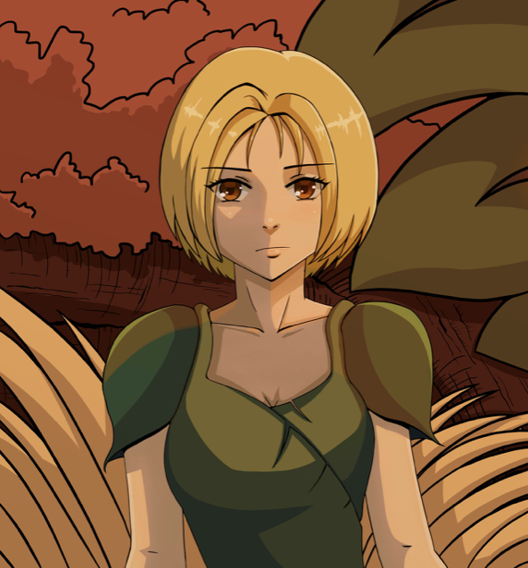
Tina, drawn by TricksterAnansi.

Story 204
Continues from Story 198. Jora and Crisis share a nice meal. Jora would like to share more… Milly tries to reconcile with Elli. Continues in Story 220.

Story 205
Continues from Story 186. In Ayralef, Ayna has found work in the fields. But Charles aspires to open her mind to the wonders of science.

Story 206: Josie
A carefree young Canadian musician playfully tries to talk strangers into letting her eat them. This story is the result of asking my readers which IVC character they would like a stand-alone story about.

Story 207
Mina has promised to meet up with new friends for a picnic. For that, though, she needs to swim up a river she’s never been up before… Continues in Story 215.

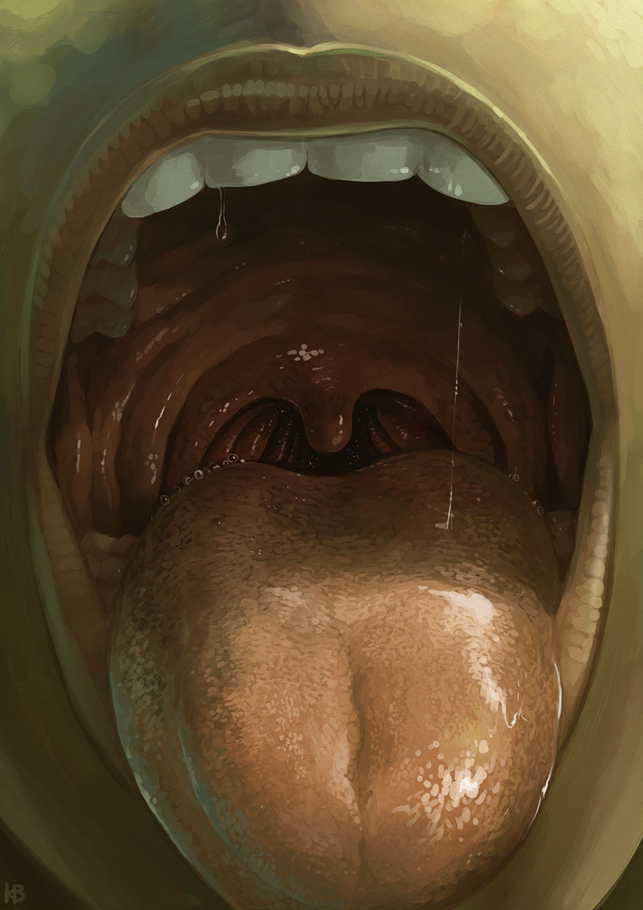
Milly’s welcoming mouth, by Karbo.

DotE ep.10: A new hope (Story 208)
The culmination of Talana’s tale. Galactic history unfolds, with very personal consequences for a Navy captain who’s also an anxious mother.

Story 209
Continues from Story 199. Clara is asked once more to turn a willing guest into food.

DotE NG ep.2: The darkness and the light (Story 210)
Dark whispers from a dead world lead Seleen and Nali into a place of insidious danger.

Story 211
It’s time for the IVC world final again! And this time they’re in Turkey, on Sahiba’s home ground. The girls’ tummies will be stuffed…

Digested ever after (Story 212)
Once upon a time, in a land now lost to legend… A man finds that his life is rather more hazardous after a sorceress casually turns him into a small fish.

…to endless night (Story 213)
In the streets of modern-day Paris, a young woman encounters a mysterious dark-haired woman playing a lute, lightly dressed in the cold winter night. That woman is a vampire…

Milly after Elli gives her… certain tips, in Story 215. Picture by Karbo.

IVC: A Christmas treat (Story 214)
At Christmas, Ida and Marlene enjoy each other’s sensual company… and a pair of excited treats. Next in Story 225.

Story 215
Milly spends some time at Elli’s hut, before heading to a picnic with friends. Continues in Story 230.

Story 216
Liri, Enita and other Felaryan fairies encounter an interesting human, at a campfire.

DotE NG ep.3: Captives (Story 217)
Our valiant Imperials no longer have pesky Rebels to fight, but the galaxy contains other threats. And when an Imperial warship hauls Seleen and her companions out of hyperspace, all may not be as it seems.

Story 218: The Odd One Out
Annikki considers her future… and hosts a ‘vore girls special’ edition of a popular quiz programme.

Story 219
Dragon-girl Amellazia very much admires the kind and lovely Princess Wilenni. She’s quite determined now to meet her… and then eat her all up.

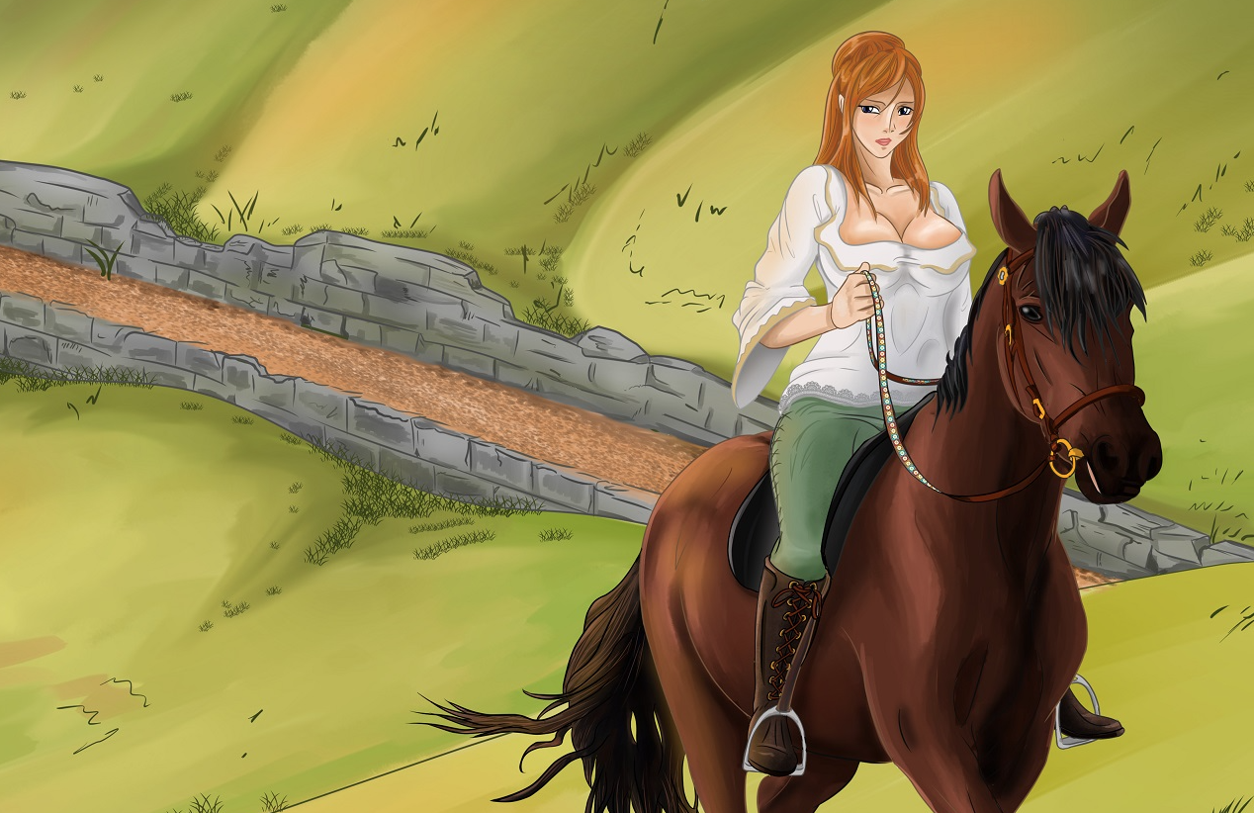
Princess Wilenni, drawn by Nalzindar to illustrate a scene from Story 219.

Story 220
Continues from Story 204. Crisis wants to do something special for Jora, and enlists her friends to help.

Le premier homme mangé sur la Lune (Story 221) - in French
Mankind is back on the Moon. Smuggled in among them, a man who wants to be eaten.

Story 222
Some simple Felaryan vore, in which a fascinated explorer ends up in Lucilya’s tummy.

Lucilya eating her catch in Story 222. Picture by Karbo.

DotE NG ep.4: The last Sith (Story 223)
Flower Shinn and Reylk discover a Force-sensitive woman trapped in carbonite, and sell her to the Empire. When the Emperor, Empress and Seleen awaken the mysterious sleeper, they soon find themselves facing a difficult decision…

Hers (Story 224)
Continues from Story 209. Clara the sorceress welcomes new guests – a young couple who want one of them to become the other’s tummy button adornment.
A Christmas swallow (Story 225)
Ida and Marlene share a special little Christmas treat. Previous in Story 214; next in Story 234.

Story 226
Jossie and her friend Lykke take their friend Teagan to the Forbidden Dish, to try out vore for the first time.

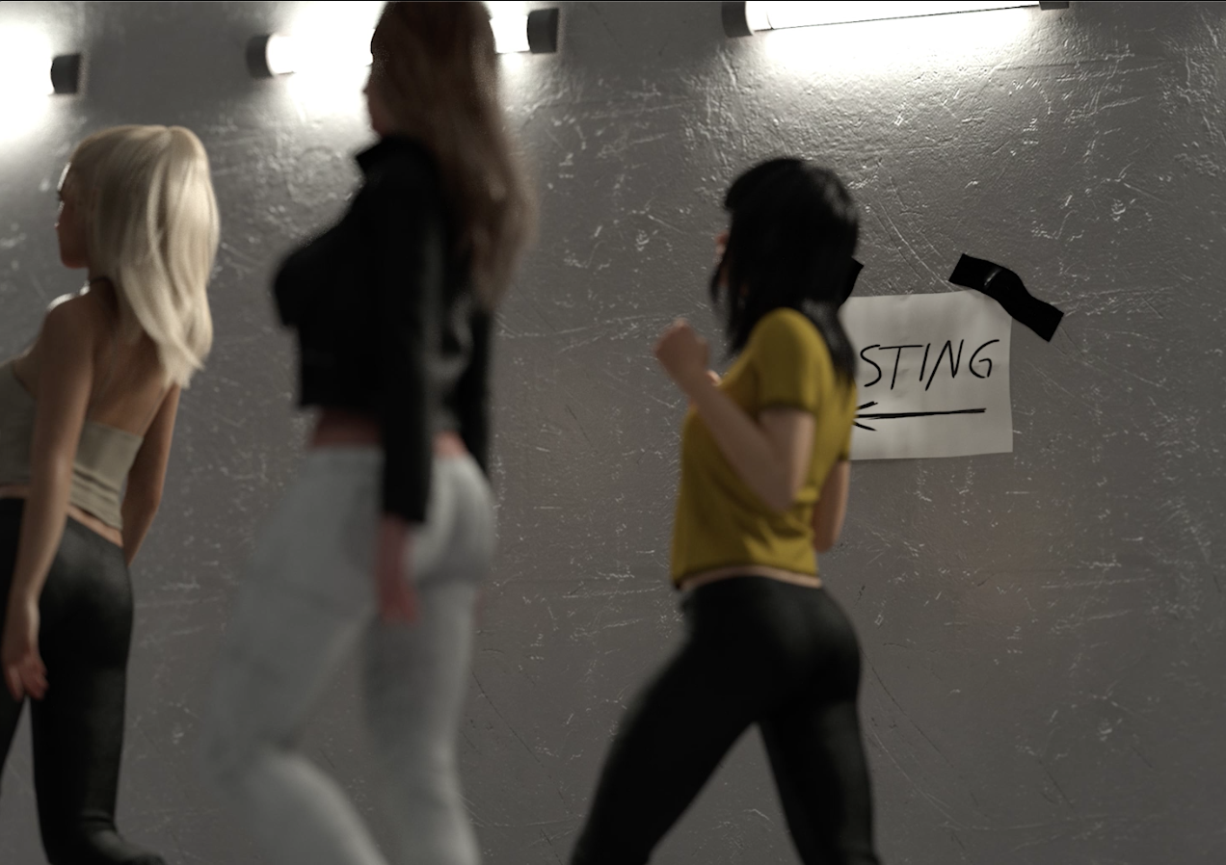
Lykke and Teagan out for some fun with Jossie. Render by TheWiking2000.

Story 227
The African vore qualifier. Vivee takes on girls from across the continent, as she fills her tummy and plays vore-chess matches for a place in the world final. And Caramel makes her tempting début!

Star Wars: Force Feeding (stories 228 and 232)
A collaborative project with Wiking. Jedi apprentice Ale’ann is out to rescue her Master on Smugglers’ Moon… and anyone who stands in her way is likely to end up shrunk in her tummy!

Earth girls are filling (story 229)
My continuation of Prinny’s delightfully vore-filled tale "Earth Girls Are Edible". A voracious young lizard has accidentally been left behind by alien visitors. Luckily, he finds food in the form of three young women to eat up!

Story 230
Continues from Story 215. Milly needs a change of scenery, and goes off for a holiday with Tinatalan and Ciel. Calina has a talk with Elli, and spots tasty mouse-girl Lixie again.

Lixie the little Felaryan neera, drawn by etharchildres.

Vampires of Venus (story 231)
A bit of speculative fiction and future history… but with vampires. Centuries from now, planet Venus has been terraformed, and is far more hospitable than Earth. Night-time on Venus lasts half a year, providing ideal conditions for vampires to mingle freely among mortals.

Story 233
Annikki, now happily married and pregnant with her second child, visits aristocratic young triplets who have emerged onto the vore scene.

Weihnachtsküsse (story 234)
Ida and Marlene’s now traditional Christmas treat. Tender love, passionate kissing, and vore! Previous in Story 225.

Story 235
The Forbidden Dish provides catering for an actress’ party in California.

Story 236
A new edition of the IVC world final! How will the new girls fare?

Nalzindar’s illustration of Story 133. Mandy looks rather annoyed at her dragon’s wilful habits!
Christmas treats (Story 237)
How are some of the girls celebrating Christmas! With a naughty little treat to eat, that’s how!

Milly and Isham, drawn by Nalzindar.

Christmas delights (Story 238)
Vivee welcomes people to her home to eat on Christmas Eve. Abena’s last day working at the Swooping Swallow comes with Christmas cheer, before she moves back to Ireland.

Story 239
Another Clara & Angie transformation vore story, making people’s dreams come true!

Lucilya eating someone, and Lucilya with food in her tummy, drawn by Karbo.

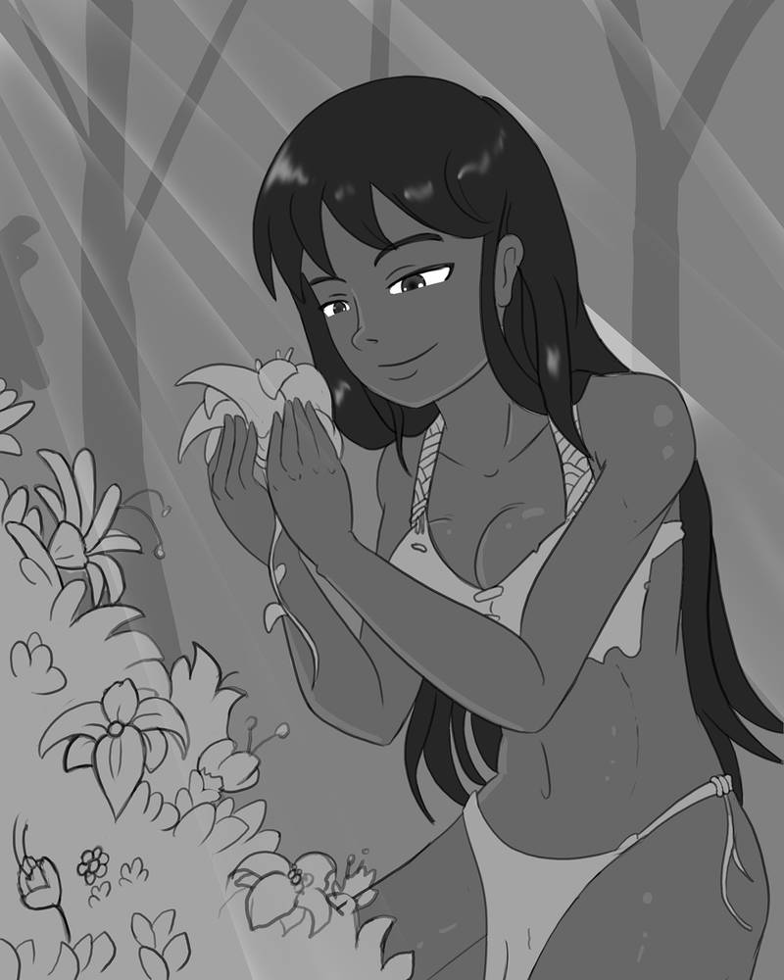
Milly enjoying the simple happiness of her garden. Picture by Vaderaz, commissioned by Asuroth.

